Work Sheet
1. Given the following equation: 2 C4H10 + 13 O2 ---> 8 CO2 + 10 H2O, show what the following molar ratios should be.

a. C4H10 / O2
b. O2 / CO2
c. O2 / H2O
d. C4H10 / CO2
e. C4H10 / H2O

2. Given the following equation: 2 KClO3 ---> 2 KCl + 3 O2

How many moles of O2 can be produced by letting 12.00 moles of KClO3 react?

3. Given the following equation: 2 K + Cl2 ---> 2 KCl

How many grams of KCl is produced from 2.50 g of K and excess Cl2. From 1.00 g of Cl2 and excess K?

4. Given the following equation: Na2O + H2O ---> 2 NaOH

How many grams of NaOH is produced from 1.20 x 102 grams of Na2O? How many grams of Na2O are required to produce 1.60 x 102 grams of NaOH?

5. Given the following equation: 8 Fe + S8 ---> 8 FeS

What mass of iron is needed to react with 16.0 grams of sulfur? How many grams of FeS are produced?

6. Given the following equation: 2 NaClO3 ---> 2 NaCl + 3 O2

12.00 moles of NaClO3 will produce how many grams of O2? How many grams of NaCl are produced when 80.0 grams of O2 are produced?

7. Given the following equation: Cu + 2 AgNO3 ---> Cu(NO3)2 + 2 Ag

How many moles of Cu are needed to react with 3.50 moles of AgNO3? If 89.5 grams of Ag were produced, how many grams of Cu reacted?

8. Molten iron and carbon monoxide are produced in a blast furnace by the reaction of iron(III) oxide and coke (pure carbon). If 25.0 kilograms of pure Fe2O3 is used, how many kilograms of iron can be produced? The reaction is: Fe2O3 + 3 C ---> 2 Fe + 3 CO

9. The average human requires 120.0 grams of glucose (C6H12O6) per day. How many grams of CO2 (in the photosynthesis reaction) are required for this amount of glucose? The photosynthetic reaction is: 6 CO2 + 6 H2O ---> C6H12O6 + 6 O2

This problem is slightly different from those above.

10. Given the reaction: 4 NH3 (g) + 5 O2 (g) ---> 4 NO (g) + 6 H2O (l)

When 1.20 mole of ammonia reacts, the total number of moles of products formed is:

- 1.20 b. 1.50 c. 1.80 d. 3.00 e. 12.0
Answers
1.
a. 2 / 13
b. 13 / 8
c. 13 / 10
d. 2 / 8 (or 1 / 4)
e. 2 / 10 (or 1 / 5)
2. The KClO₃ / O₂ molar ratio is 2/3.
2 mol KClO₃ / 3 mol. O₂ = 12.00 mol KClO₃ / x = 18.00 mol.
x = 18.00 mol of O₂
3. Given the following equation: 2 K + Cl₂ ---> 2 KCl
How many grams of KCl is produced from 2.50 g of K and excess Cl₂.
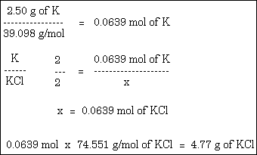
From 1.00 g of Cl₂ and excess K?
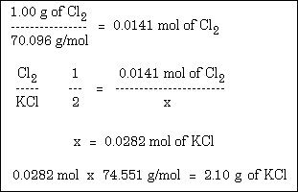
4. Given the following equation: Na₂O + H₂O ---> 2 NaOH
How many grams of NaOH is produced from 1.20 x 10² grams of Na₂O?
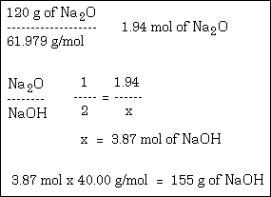
How many grams of Na₂O are required to produce 1.60 x 10² grams of NaOH?
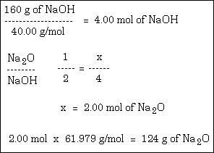
5. Given the following equation: 8 Fe + S₈ ---> 8 FeS
What mass of iron is needed to react with 16.0 grams of sulfur?
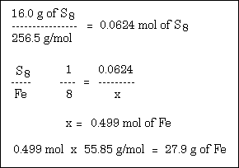
How many grams of FeS are produced?
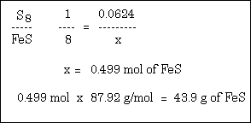
6. Given the following equation: 2 NaClO₃ ---> 2 NaCl + 3 O₂
12.00 moles of NaClO₃ will produce how many grams of O₂?
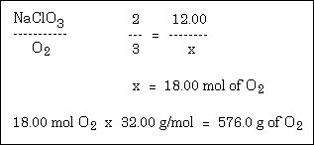
How many grams of NaCl are produced when 80.0 grams of O₂ are produced?
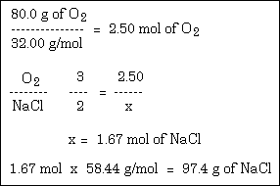
7. Given the following equation: Cu + 2 AgNO₃ ---> Cu(NO₃)₂ + 2 Ag
How many moles of Cu are needed to react with 3.50 moles of AgNO₃?
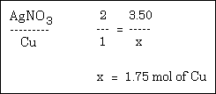
If 89.5 grams of Ag were produced, how many grams of Cu reacted?
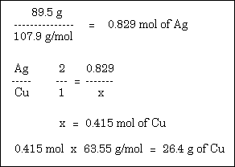
8. Molten iron and carbon monoxide are produced in a blast furnace by the reaction of iron(III) oxide and coke (pure carbon). If 25.0 kilograms of pure Fe₂O₃ is used, how many kilograms of iron can be produced? The reaction is: Fe₂O₃ + 3 C ---> 2 Fe + 3 CO
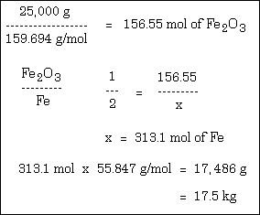
9. The average human requires 120.0 grams of glucose (C₆H₁₂O₆) per day. How many grams of CO₂ (in the photosynthesis reaction) are required for this amount of glucose? The photosynthetic reaction is: 6 CO₂ + 6 H₂O ---> C₆H₁₂O₆ + 6 O₂
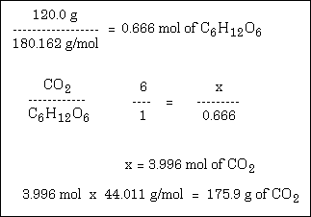
This problem is slightly different from those above.
10. Given the reaction: 4 NH₃ (g) + 5 O₂ (g) ---> 4 NO (g) + 6 H₂O (l)
When 1.20 mole of ammonia reacts, the total number of moles of products formed is:
a. 1.20 b. 1.50 c. 1.80 d. 3.00 e. 12.0
The correct answer is d.
NH₃ / (NO + H₂O) = 4 / 10
4 / 10 = 1.20 / x
x = 3.00 mol

