Practice Problems
Calculate the moles present in:
1) 2.00 grams of H₂O
2) 75.57 grams of KBr
3) 100. grams of KClO₄
4) 8.76 grams of NaOH
5) 0.750 grams of Na₂CO₃

Answers
1) 2.00 grams of H₂O
Step One: the problem gives 2.00 grams
Step Two: the molar mass of H₂O is 18.015 grams/mole
Step Three: 2.00 grams ÷ 18.015 grams/mole = 0.111 mole (when rounded off to the correct number of significant figures)
The three steps, put together, look like this:
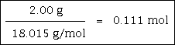
Set up as a proportion, the problem looks like this:
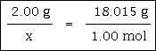

2) 75.57 grams of KBr
Step One: the problem gives 75.57 grams
Step Two: the molar mass of KBr is 119.0023 grams/mole
Step Three: 75.57 grams ÷ 119.0023 grams/mole = 0.6350 mole (when rounded off to the correct number of significant figures)
The three steps, put together, look like this:
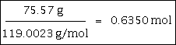
Set up as a proportion, the problem looks like this:
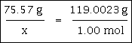

3) 100. grams of KClO₄
Step One: the problem gives 100. grams (note three significant figures)
Step Two: the molar mass of KClO₄ is 138.549 grams/mole
Step Three: 100. grams ÷ 138.549 grams/mole = 0.722 mole (when rounded off to the correct number of significant figures)
The three steps, put together, look like this:
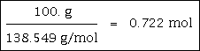
Set up as a proportion, the problem looks like this:
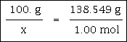

4) 8.76 grams of NaOH
Step One: the problem gives 8.76 grams
Step Two: the molar mass of NaOH is 39.997 grams/mole
Step Three: 8.76 grams ÷ 39.997 grams/mole = 0.219 mole (when rounded off to the correct number of significant figures)
The three steps, put together, look like this:
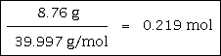
Set up as a proportion, the problem looks like this:
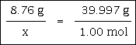

5) 0.750 grams of Na₂CO₃
Step One: the problem gives 0.750 grams (note three significant figures)
Step Two: the molar mass of Na₂CO₃ is 105.989 grams/mole
Step Three: 0.750 grams ÷ 105.989 grams/mole = 7.08 x 10¯³ mole (when rounded off to the correct number of significant figures)
Please note that 7.08 x 10¯³ can be expressed as 0.00708.
The three steps, put together, look like this:
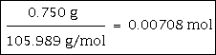
Set up as a proportion, the problem looks like this:
