- Measure the length and width of the rectangle below using a regular ruler. Give both the absolute and relative uncertainty.

2.59 cm ± 0.05 cm
Relative = 0.05 cm x 100
2.59
= 1.93 %
2.59 cm ± 1.93 %

5.95 cm ± 0.05 cm
Relative = 0.05 cm x 100
5.95
= 0.840 %
5.95 cm ± 0.84%

- Read the volume of the liquid in the graduated cylinder. The volume is in milliliters.
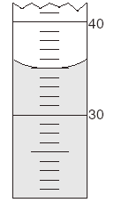

35.0 mL ± 0.5 mL
The uncertainty and the measurement must have the same number of decimal places.

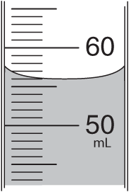
- Indicate the volume of the liquid in the graduated cylinder. Include the absolute and relative uncertainty.

Absolute = 56.0 mL ± .05 mL
Relative = 0.5 mL x 100
56.0 mL
= 0.893%
56.0 mL ± 0.893%

